1. Enhanced the HTML application by adding support to Karate with Java
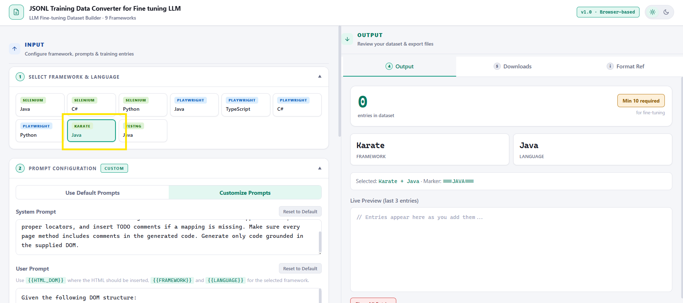

2. Generated output files for the given training data 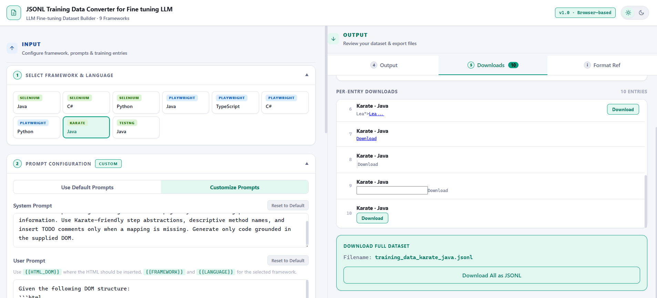

3. Downloaded the output files
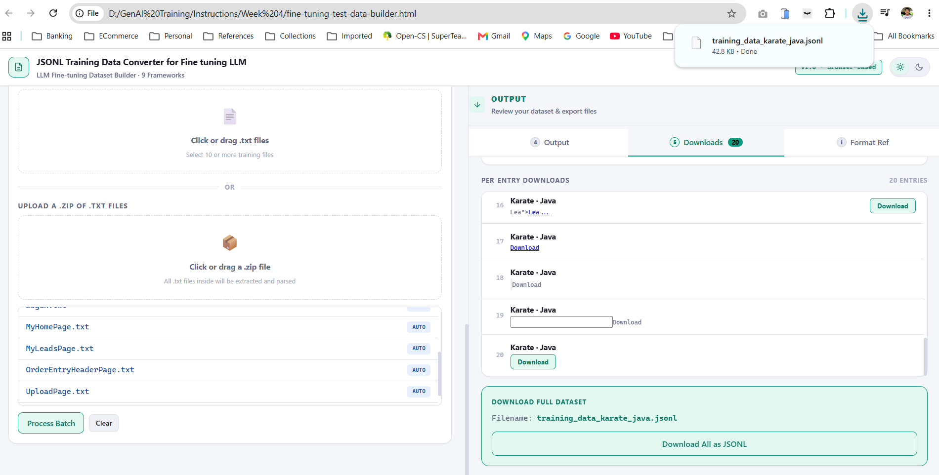
4. Formatted downloaded file
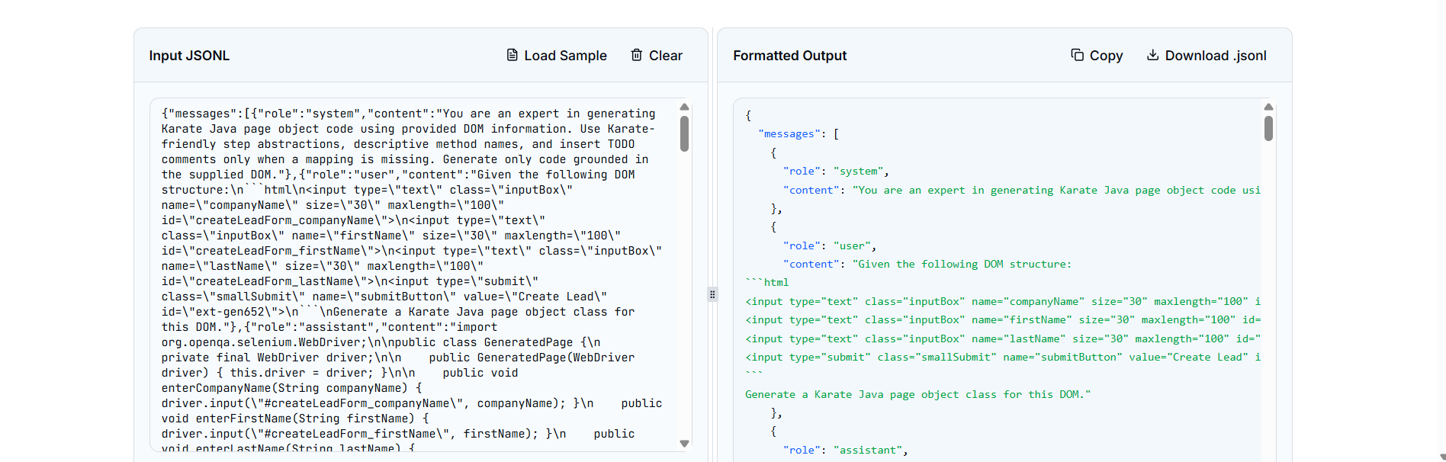
Downloaded File
{
"messages": [
{
"role": "system",
"content": "You are an expert in generating Karate Java page object code using provided DOM information. Use Karate-friendly step abstractions, descriptive method names, and insert TODO comments only when a mapping is missing. Generate only code grounded in the supplied DOM."
},
{
"role": "user",
"content": "Given the following DOM structure:\n```html\n<input type=\"text\" class=\"inputBox\" name=\"companyName\" size=\"30\" maxlength=\"100\" id=\"createLeadForm_companyName\">\n<input type=\"text\" class=\"inputBox\" name=\"firstName\" size=\"30\" maxlength=\"100\" id=\"createLeadForm_firstName\">\n<input type=\"text\" class=\"inputBox\" name=\"lastName\" size=\"30\" maxlength=\"100\" id=\"createLeadForm_lastName\">\n<input type=\"submit\" class=\"smallSubmit\" name=\"submitButton\" value=\"Create Lead\" id=\"ext-gen652\">\n```\nGenerate a Karate Java page object class for this DOM."
},
{
"role": "assistant",
"content": "import org.openqa.selenium.WebDriver;\n\npublic class GeneratedPage {\n private final WebDriver driver;\n\n public GeneratedPage(WebDriver driver) { this.driver = driver; }\n\n public void enterCompanyName(String companyName) { driver.input(\"#createLeadForm_companyName\", companyName); }\n public void enterFirstName(String firstName) { driver.input(\"#createLeadForm_firstName\", firstName); }\n public void enterLastName(String lastName) { driver.input(\"#createLeadForm_lastName\", lastName); }\n public void clickSubmitButton() { driver.click(\"#ext-gen652\"); }\n}"
}
]
}

{
"messages": [
{
"role": "system",
"content": "You are an expert in generating Karate Java page object code using provided DOM information. Use Karate-friendly step abstractions, descriptive method names, and insert TODO comments only when a mapping is missing. Generate only code grounded in the supplied DOM."
},
{
"role": "user",
"content": "Given the following DOM structure:\n```html\n<input type=\"text\" size=\"20\" autocomplete=\"off\" id=\"ext-gen246\" name=\"id\" class=\" x-form-text x-form-field \" style=\"width: 214px;\"> \n<input type=\"text\" size=\"20\" autocomplete=\"off\" id=\"ext-gen248\" name=\"firstName\" class=\" x-form-text x-form-field \" style=\"width: 214px;\"> \n<input type=\"text\" size=\"20\" autocomplete=\"off\" id=\"ext-gen250\" name=\"lastName\" class=\" x-form-text x-form-field \" style=\"width: 214px;\"> \n<input type=\"text\" size=\"20\" autocomplete=\"off\" id=\"ext-gen252\" name=\"companyName\" class=\" x-form-text x-form-field \" style=\"width: 214px;\"> \n<button class=\"x-btn-text\" type=\"button\" id=\"ext-gen334\">Find Leads</button>\n```\nGenerate a Karate Java page object class for this DOM."
},
{
"role": "assistant",
"content": "import org.openqa.selenium.WebDriver;\n\npublic class GeneratedPage {\n private final WebDriver driver;\n\n public GeneratedPage(WebDriver driver) { this.driver = driver; }\n\n public void enterId(String id) { driver.input(\"#ext-gen246\", id); }\n public void enterFirstName(String firstName) { driver.input(\"#ext-gen248\", firstName); }\n public void enterLastName(String lastName) { driver.input(\"#ext-gen250\", lastName); }\n public void enterCompanyName(String companyName) { driver.input(\"#ext-gen252\", companyName); }\n public void clickExtGen334() { driver.click(\"#ext-gen334\"); }\n}"
}
]
}

{
"messages": [
{
"role": "system",
"content": "You are an expert in generating Karate Java page object code using provided DOM information. Use Karate-friendly step abstractions, descriptive method names, and insert TODO comments only when a mapping is missing. Generate only code grounded in the supplied DOM."
},
{
"role": "user",
"content": "Given the following DOM structure:\n```html\n<input type=\"text\" size=\"20\" autocomplete=\"off\" id=\"ext-gen253\" name=\"id\" class=\" x-form-text x-form-field\" style=\"width: 214px;\">\n<input type=\"text\" size=\"20\" autocomplete=\"off\" id=\"ext-gen255\" name=\"firstName\" class=\" x-form-text x-form-field\" style=\"width: 214px;\">\n<input type=\"text\" size=\"20\" autocomplete=\"off\" id=\"ext-gen253\" name=\"id\" class=\" x-form-text x-form-field\" style=\"width: 214px;\">\n<input type=\"text\" size=\"20\" autocomplete=\"off\" id=\"ext-gen253\" name=\"id\" class=\" x-form-text x-form-field\" style=\"width: 214px;\">\n<button class=\"x-btn-text\" type=\"button\" id=\"ext-gen341\">Find Leads</button>\n```\nGenerate a Karate Java page object class for this DOM."
},
{
"role": "assistant",
"content": "import org.openqa.selenium.WebDriver;\n\npublic class GeneratedPage {\n private final WebDriver driver;\n\n public GeneratedPage(WebDriver driver) { this.driver = driver; }\n\n public void enterId(String id) { driver.input(\"#ext-gen253\", id); }\n public void enterFirstName(String firstName) { driver.input(\"#ext-gen255\", firstName); }\n public void clickExtGen341() { driver.click(\"#ext-gen341\"); }\n}"
}
]
}

{
"messages": [
{
"role": "system",
"content": "You are an expert in generating Karate Java page object code using provided DOM information. Use Karate-friendly step abstractions, descriptive method names, and insert TODO comments only when a mapping is missing. Generate only code grounded in the supplied DOM."
},
{
"role": "user",
"content": "Given the following DOM structure:\n```html\n<a style=\"color: black;\" href=\"/crmsfa/control/main?externalLoginKey=EL601288709152\">\nCRM/SFA\n</a>\n<input class=\"decorativeSubmit\" style=\"width:65px; margin-left:1px;\" type=\"submit\" value=\"Logout\">\n```\nGenerate a Karate Java page object class for this DOM."
},
{
"role": "assistant",
"content": "import org.openqa.selenium.WebDriver;\n\npublic class GeneratedPage {\n private final WebDriver driver;\n\n public GeneratedPage(WebDriver driver) { this.driver = driver; }\n\n public void clickCRMSFA() { driver.click(\"a\"); }\n public void clickLogout() { driver.click(\"input[type=\"submit\"]\"); }\n}"
}
]
}

{
"messages": [
{
"role": "system",
"content": "You are an expert in generating Karate Java page object code using provided DOM information. Use Karate-friendly step abstractions, descriptive method names, and insert TODO comments only when a mapping is missing. Generate only code grounded in the supplied DOM."
},
{
"role": "user",
"content": "Given the following DOM structure:\n```html\n<input class=\"inputLogin\" type=\"text\" id=\"username\" name=\"USERNAME\" size=\"50\">\n<input class=\"inputLogin\" type=\"password\" id=\"password\" name=\"PASSWORD\" size=\"50\">\n<input class=\"decorativeSubmit\" type=\"submit\" value=\"Login\">\n```\nGenerate a Karate Java page object class for this DOM."
},
{
"role": "assistant",
"content": "import org.openqa.selenium.WebDriver;\n\npublic class GeneratedPage {\n private final WebDriver driver;\n\n public GeneratedPage(WebDriver driver) { this.driver = driver; }\n\n public void enterUsername(String username) { driver.input(\"#username\", username); }\n public void enterPassword(String password) { driver.input(\"#password\", password); }\n public void clickLogin() { driver.click(\"input[type=\"submit\"]\"); }\n}"
}
]
}

{
"messages": [
{
"role": "system",
"content": "You are an expert in generating Karate Java page object code using provided DOM information. Use Karate-friendly step abstractions, descriptive method names, and insert TODO comments only when a mapping is missing. Generate only code grounded in the supplied DOM."
},
{
"role": "user",
"content": "Given the following DOM structure:\n```html\n<a href=\"/crmsfa/control/leadsMain\" id=\"ext-gen614\">Leads</a>\n```\nGenerate a Karate Java page object class for this DOM."
},
{
"role": "assistant",
"content": "import org.openqa.selenium.WebDriver;\n\npublic class GeneratedPage {\n private final WebDriver driver;\n\n public GeneratedPage(WebDriver driver) { this.driver = driver; }\n\n public void clickExtGen614() { driver.click(\"#ext-gen614\"); }\n}"
}
]
}

{
"messages": [
{
"role": "system",
"content": "You are an expert in generating Karate Java page object code using provided DOM information. Use Karate-friendly step abstractions, descriptive method names, and insert TODO comments only when a mapping is missing. Generate only code grounded in the supplied DOM."
},
{
"role": "user",
"content": "Given the following DOM structure:\n```html\n<a href=\"/crmsfa/control/createLeadForm\" id=\"ext-gen876\">Create Lead</a>\n```\nGenerate a Karate Java page object class for this DOM."
},
{
"role": "assistant",
"content": "import org.openqa.selenium.WebDriver;\n\npublic class GeneratedPage {\n private final WebDriver driver;\n\n public GeneratedPage(WebDriver driver) { this.driver = driver; }\n\n public void clickExtGen876() { driver.click(\"#ext-gen876\"); }\n}"
}
]
}

{
"messages": [
{
"role": "system",
"content": "You are an expert in generating Karate Java page object code using provided DOM information. Use Karate-friendly step abstractions, descriptive method names, and insert TODO comments only when a mapping is missing. Generate only code grounded in the supplied DOM."
},
{
"role": "user",
"content": "Given the following DOM structure:\n```html\n<input class=\"XdijitInputField dijitInputFieldValidationNormal\" type=\"text\" autocomplete=\"off\" name=\"ComboBox_productId\" dojoattachevent=\"onkeypress, onkeyup, onfocus, onblur, compositionend\" dojoattachpoint=\"textbox,focusNode\" id=\"ComboBox_productId\" tabindex=\"1\" size=\"15\" maxlength=\"50\" wairole=\"combobox\" role=\"wairole:combobox\" value=\"\" valuenow=\"\" invalid=\"false\" disabled=\"false\">\n<input id=\"quantity\" name=\"quantity\" type=\"text\" size=\"10\" maxlength=\"\" class=\"inputBox\" value=\"1\" onchange=\"\" tabindex=\"2\">\n<a class=\"subMenuButton\" href=\"javascript:document.cartform.submit();\" id=\"ext-gen173\">Update</a>\n```\nGenerate a Karate Java page object class for this DOM."
},
{
"role": "assistant",
"content": "import org.openqa.selenium.WebDriver;\n\npublic class GeneratedPage {\n private final WebDriver driver;\n\n public GeneratedPage(WebDriver driver) { this.driver = driver; }\n\n public void enterComboBoxProductId(String comboBoxProductId) { driver.input(\"#ComboBox_productId\", comboBoxProductId); }\n public void enterQuantity(String quantity) { driver.input(\"#quantity\", quantity); }\n public void clickExtGen173() { driver.click(\"#ext-gen173\"); }\n}"
}
]
}

{
"messages": [
{
"role": "system",
"content": "You are an expert in generating Karate Java page object code using provided DOM information. Use Karate-friendly step abstractions, descriptive method names, and insert TODO comments only when a mapping is missing. Generate only code grounded in the supplied DOM."
},
{
"role": "user",
"content": "Given the following DOM structure:\n```html\n<input id=\"uploadedFile\" name=\"uploadedFile\" type=\"file\" size=\"30\" maxlength=\"\" class=\"inputBox\" onchange=\"\">\n<input type=\"submit\" value=\"Upload and Import\" class=\"smallSubmit\" onclick=\"submitFormAndReplaceButtonTextWithSingleClick(this, 'Uploading... Please Wait');\" id=\"ext-gen593\">\n```\nGenerate a Karate Java page object class for this DOM."
},
{
"role": "assistant",
"content": "import org.openqa.selenium.WebDriver;\n\npublic class GeneratedPage {\n private final WebDriver driver;\n\n public GeneratedPage(WebDriver driver) { this.driver = driver; }\n\n public void enterUploadedFile(String uploadedFile) { driver.input(\"#uploadedFile\", uploadedFile); }\n public void clickExtGen593() { driver.click(\"#ext-gen593\"); }\n}"
}
]
}

{
"messages": [
{
"role": "system",
"content": "You are an expert in generating Karate Java page object code using provided DOM information. Use Karate-friendly step abstractions, descriptive method names, and insert TODO comments only when a mapping is missing. Generate only code grounded in the supplied DOM."
},
{
"role": "user",
"content": "Given the following DOM structure:\n```html\n<div class=\"x-grid3-cell-inner x-grid3-col-partyId\" unselectable=\"on\" id=\"ext-gen781\"><a class=\"linktext\" href=\"/crmsfa/control/viewLead?partyId=10196\" id=\"ext-gen839\">10196</a></div>\n<div class=\"x-grid3-cell-inner x-grid3-col-firstName\" unselectable=\"on\" id=\"ext-gen840\"><a class=\"linktext\" href=\"/crmsfa/control/viewLead?partyId=10196\" id=\"ext-gen841\">TCS</a></div>\n<div class=\"x-grid3-cell-inner x-grid3-col-lastName\" unselectable=\"on\" id=\"ext-gen842\"><a class=\"linktext\" href=\"/crmsfa/control/viewLead?partyId=10196\" id=\"ext-gen874\">Abd</a></div>\n<div class=\"x-grid3-cell-inner x-grid3-col-companyName\" unselectable=\"on\" id=\"ext-gen857\"><a class=\"linktext\" href=\"/crmsfa/control/viewLead?partyId=10196\" id=\"ext-gen858\">M S</a></div>\n```\nGenerate a Karate Java page object class for this DOM."
},
{
"role": "assistant",
"content": "import org.openqa.selenium.WebDriver;\n\npublic class GeneratedPage {\n private final WebDriver driver;\n\n public GeneratedPage(WebDriver driver) { this.driver = driver; }\n\n public void clickExtGen839() { driver.click(\"#ext-gen839\"); }\n public void clickExtGen841() { driver.click(\"#ext-gen841\"); }\n public void clickExtGen874() { driver.click(\"#ext-gen874\"); }\n public void clickExtGen858() { driver.click(\"#ext-gen858\"); }\n}"
}
]
}

